New documentary examines Cornish farming’s place in fighting the climate crisis

WATCH THE FILM TRAILER HERE: https://youtu.be/aeHWhuI8ng8
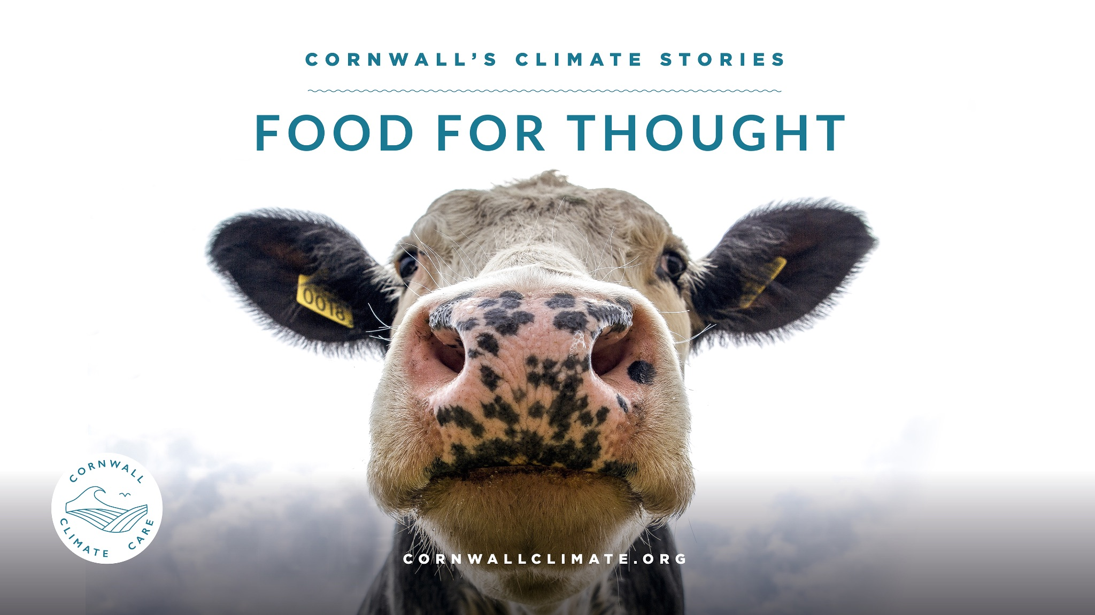
A new documentary Food for Thought released in January 2023 takes a ‘behind the headlines’ look at the claims around the climate impact of livestock farming – and what this means for Cornwall.
This is the latest film from charity Cornwall Climate Care (cornwallclimate.org), and is presented by organic farmer Lisa Guy, who farms a herd of beef cattle near Land’s End.
Animal agriculture is estimated to contribute more to the world’s greenhouse gas emissions than transport, with everyone from the United Nations to the UK government’s own advisors, the Committee on Climate Change, saying we must significantly reduce meat and dairy consumption if we’re to have a chance of getting climate change under control but is the issue as black and white as it seems?
Globally, meat consumption is rising fast, and animal farming is a major driver of deforestation, uses up a huge amount of the world’s land and water, and is responsible for a range of other pollution and environmental impacts.
But what does this mean for Cornwall, where our whole landscape has been shaped by centuries of animal agriculture? Since much of our land is best suited to growing grass, the majority of everything farmed here is either livestock or food for those animals to eat.
In the film, Lisa looks at the more nuanced picture of whether pasture-fed Cornish animals have the same climate impact as intensively reared cattle, fed on soya grown in what might recently have been Amazonian rainforest.
It also looks in-depth at the many initiatives locally working to minimise the impact of livestock farming and also to boost regenerative livestock techniques, which can play an important role in fighting climate change by maintaining the health of the soil, one of the world’s largest carbon sinks.
The film includes interviews with a wide range of voices including:
- an engineer who helped develop satellite systems to monitor the ozone hole – now using that expertise to convert gases from cattle waste into a green fuel
- an experimental dairy unit where novel feeds including spent brewing grains and broken biscuits are being trialled in an attempt to reduce cows’ carbon footprint
- a farmer who’s totally changed the way he sows his crops to help lock carbon into the soil
- an Animal Rebellion activist, campaigning for animal agriculture to be phased out altogether
- an egg company director calling for lifting of the post-BSE ban on use of processed slaughterhouse waste in animal feed – in order to reduce climate emissions
- One of Cornwall’s three ‘net zero’ farmers, who has taken up the challenge of proving his farm can become carbon neutral within five years
Cornwall’s Climate Stories is a series of 12 documentaries being produced over the next few years, looking at various issues around climate change right here in Cornwall – how it is going to impact us and the inspiring stories of what local people are doing to address these challenges.
The series has been praised by Sir David Attenborough, who said: “The need you have identified is indeed a real one, and your films meet it very well. Congratulations.”
Producer Claire Wallerstein said: “With greenhouse gas emissions still rising every year, the window for meaningful action on the climate crisis is rapidly closing, but sadly, conversation around it these days so often seems to have become reduced to angry shouting.
“With these films we really want to let people tell their own stories, showcase the practical action they’re taking, and create a space where everyone can be listened to.”
A follow-up film, Hungry for Change, coming in the Spring, will look more closely at issues such as food waste, food miles, and what Cornwall could do to produce much more of its own food.
‘Food for Thought’ will be launched at MULTIPLE screening events, along with Q&A from the filmmakers and some of the participants, throughout January, Find all the information below

5th January 2023
Screening at ORFC - Oxford Real Farming Conference
Museum Makers Space @ 13:00-14:00
Get your tickets here - https://www.tickettailor.com/events/oxfordrealfarmingconference/717391

8th January 2023
Screening at Calstock Arts
Calstock Arts Chapel @ 19:00
Tickets available on the door
Join the event here - https://www.facebook.com/events/893974468640972

12th January 2023
Screening at St Ives Art Club
Followed by Q&A and a food waste supper provided by [name] @ 18:00
https://www.facebook.com/events/724927211956634/
Get your tickets here - https://www.eventbrite.co.uk/e/487523404627

14th January 2023
Special screening at Plaza Cinema Truro @ 17:00
https://www.facebook.com/events/635870404945362/
Get your tickets here - https://www.eventbrite.co.uk/e/487548519747

22nd January 2023
Screening at Maker with Rame Community Hall, Kingsand
Followed by Q&A - 19:00
https://www.facebook.com/events/845446583368574/
Get your tickets here - https://www.eventbrite.co.uk/e/483829726737

26th January 2023
Screening at Wadebridge Renewable Energy Network - WREN Net Zero Community (NZCom) - 'Your energy transition to NZ' Event
More details coming soon

The film will be freely available on the Cornwall Climate Care website (cornwallclimate.org/films ) or on our Youtube channel from early February 2023
Follow us on social media for more information about live screenings and online launch of the film in January 2023: https://linktr.ee/CornwallClimateCare,
For more information or to organise a screening contact: gill@cornwallclimate.org

